WEEK : 05

Microservices with Spring Boot 3 and Spring cloud

Exercise : Creating Microservices for account & loan

#Account logic code

package com.cognizant.account;

import org.springframework.web.bind.annotation.GetMapping;

import org.springframework.web.bind.annotation.PathVariable;

import org.springframework.web.bind.annotation.RestController;

@RestController

public class AccountController {

@GetMapping("/accounts/{number}")

public String getAccountDetails(@PathVariable String number) {

String response = "{ \"number\": \"" + number + "\", \"type\": \"savings\", \"balance\": 234343 }";

return response;

}

}

class Account {

public String number;

public String type;

public double balance;

public Account(String number, String type, double balance) {

this.number = number;

this.type = type;

this.balance = balance;

}

}

}

OUTPUT :

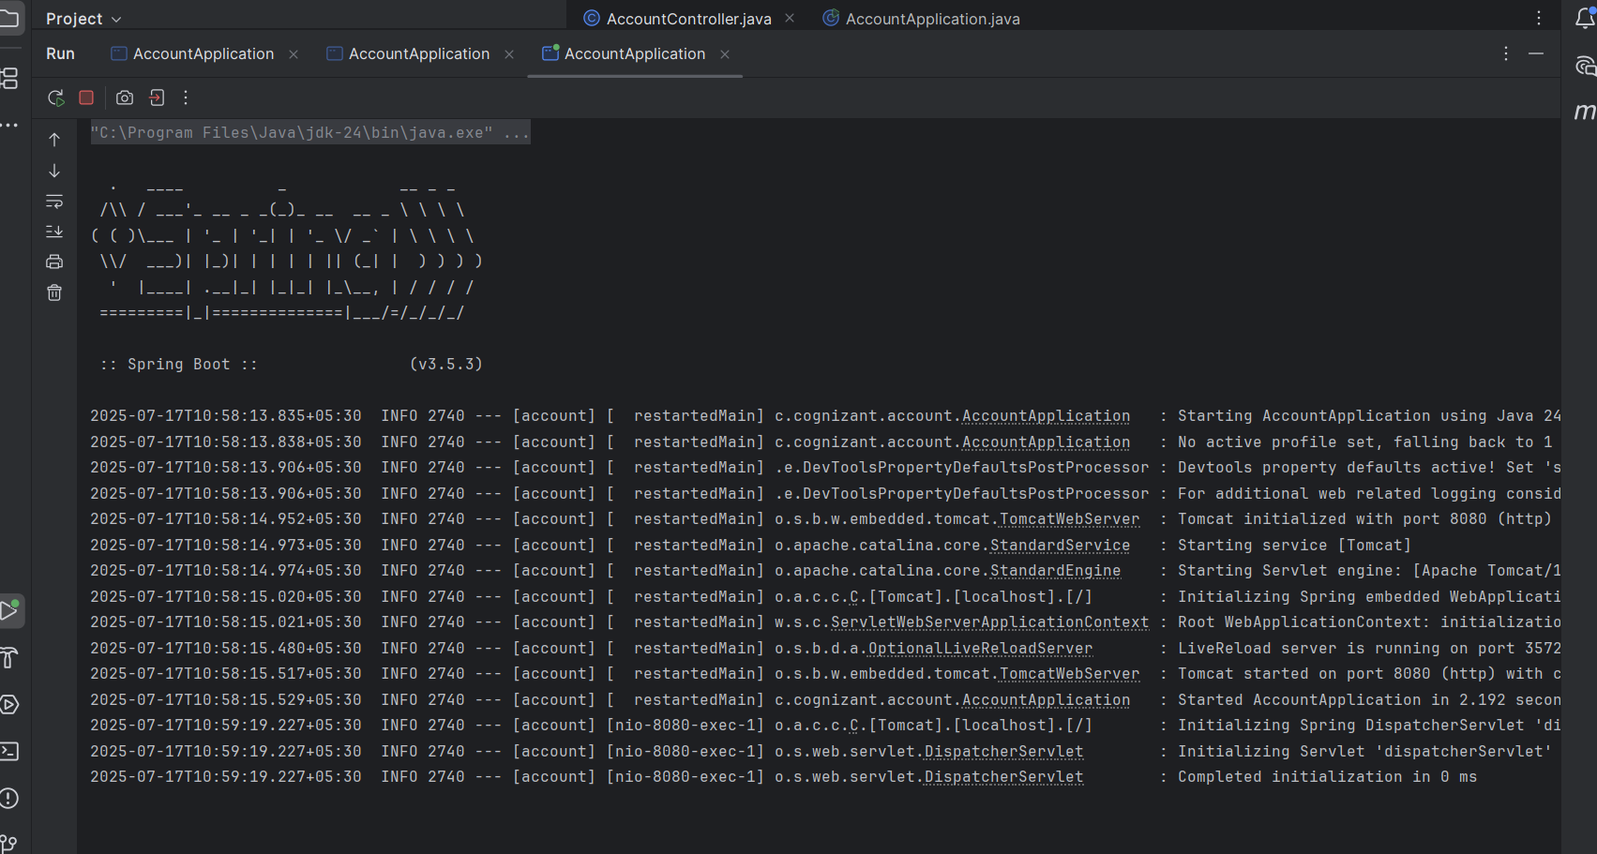

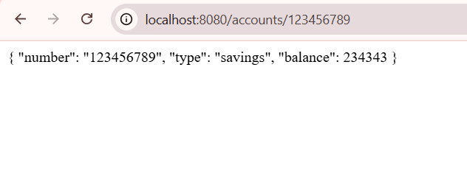#LoanController logic code

package com.cognizant.account.loan;

import org.springframework.web.bind.annotation.GetMapping;

import org.springframework.web.bind.annotation.PathVariable;

import org.springframework.web.bind.annotation.RestController;

import java.util.HashMap;

import java.util.Map;

@RestController

public class LoanController {

@GetMapping("/loans/{number}")

public Map<String, Object> getLoanDetails(@PathVariable("number") String loanNumber) {

Map<String, Object> loanDetails = new HashMap<>();

loanDetails.put("number", loanNumber);

loanDetails.put("type", "car");

loanDetails.put("loan", 400000);

loanDetails.put("emi", 3258);

loanDetails.put("tenure", 18);

return loanDetails;

}

}

# Application properties

Server.port=8081

OUTPUT :

